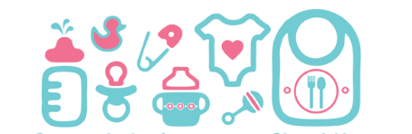

Palmetto Presbyterian Preschool
Infant’s checklist

- Formula or Breast milk
- 3 bottles
- 3 Changes of cloths
- Fitted sheet cover for the crib
(Goes home on Friday to be washed and brought back the following Monday.)
- Diaper Box
- Diaper cream
- Baby wipes packet
- 2-3 Burp cloths
- 2 Bibs
- (1) pacifier (1) pacifier with clip
- 2 Snacks

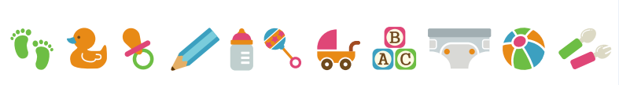
*All items MUST be labeled with the Childs first and last name*

