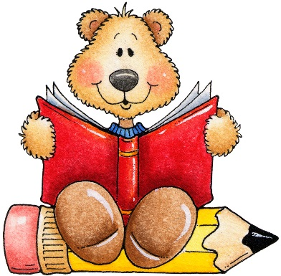

Palmetto Presbyterian Preschool
K-2 checklist

- Sippy cup
- Changes of cloths
(Please include underwear/socks and shoes)

- Fitted sheet cover for the crib
(Goes home on Friday to be washed and brought back the following Monday.)

- Diapers / Pull ups
- Diaper cream
- Baby wipes packet
- (1) Healthy morning snack (1) afternoon snack

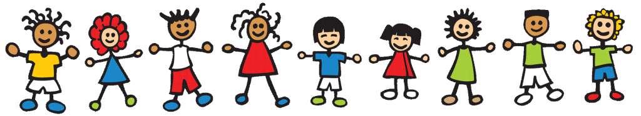
*All items MUST be labeled with the Childs first and last name*

